Discoverers/Navigators/Pathfinders/Pioneers

Term | Autumn 1 | Autumn 2 | Spring 1 | Spring 2 | Summer 1 | Summer 2
Topic | 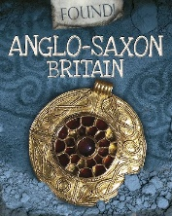  Anglo-Saxon Britain  AQA 123070 | 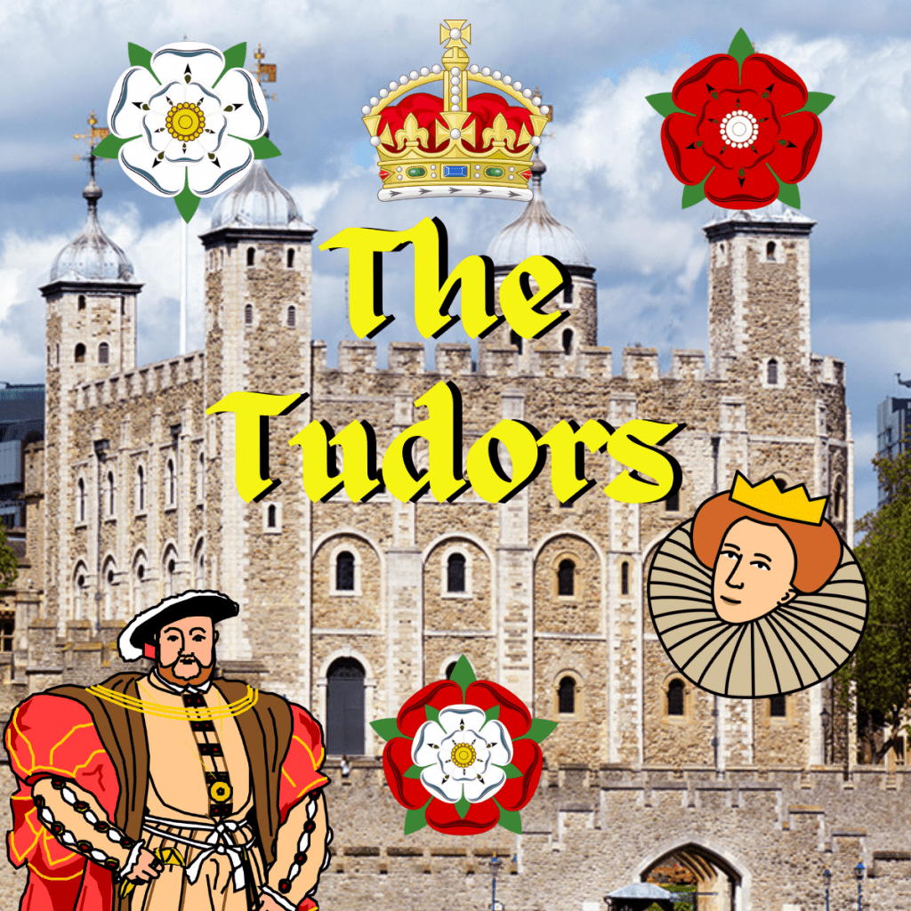  Tudor Britain  AQA 123584 | 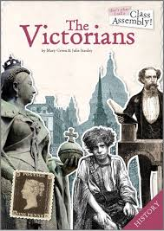  The Victorians  AQA 88205 | 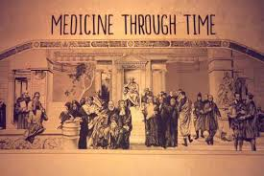  Medicine Through Time  AQA 119734 |   Local History | 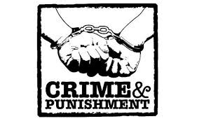  Crime and Punishment  AQA 122150
Pre-Teaching Assessment Suggestions | Multiple choice quiz  Entry Questions | Multiple choice quiz  Entry Questions | Multiple choice quiz  Entry Questions | Multiple choice quiz  Entry Questions | Multiple choice quiz  Entry Questions | Multiple choice quiz  Entry Questions
‘Step On’ Knowledge | Explore how the main ways the control of Britain changed after the Romans left.  Explain how the main ways the control of Britain changed after the Romans left.  Explore the key characteristics of life in Anglo-Saxon Britain. | Explore who the first Tudor king was and how he became king.  Explore who Henry VIII was.  Explain why Henry VIII is historically important (at least two reasons).  Explore the ways Henry VIII changed how the churches worked.  Explore and explain the key reasons why the Tudor period ended.  Display the Tudor monarchs on a time line making the final monarch clear. | Explore two aspects of home life for rich Victorians.  Explore tow aspects of life for poor Victorians.  Identify two difference between kitchens in Victorian times and now.  Cook a Victorian recipe. | Create a timeline if key events and discoveries linked to medicine.  Explore the believed causes of disease during different time periods.  Explore the impact religion has on medical progress. | Speak to Helen about the person they want to focus on! | Describe the key crimes, punishments and law enforcement in Anglo-Saxon England.  Describe the key crimes, punishments and law enforcement in Norman England.  Describe the key crimes, punishments and law enforcement in the later Middle Ages.  Explore the key influences of the church on crime and punishment.
‘Extending up’ Knowledge | Create a timeline of events during the Anglo-Saxon era.  Explain who ruled Anglo-Saxon Britain.  Explore how written sources can inform about life in Anglo-Saxon Britain.  Explore Anglo-Saxon burh designs.  Use digital tools to design an Anglo-Saxon burh.  Make a class Anglo-Saxon burh. | Identify and explain who at least 3 Tudor monarchs were.  Identify at least 3 of Henry VIII’s wives and explain what happened to them.  Identify and explain at least two things Henry VIII was famous for during his reign.  Explain with detail the reasons why Henry VIII made his won church.  Explain with key reasons why the Tudor period ended. | Compare and contrast schools in Victorian times and now.  Compare and contrast shops/towns in Victorian times and now.  Explore Queen Victoria’s life.  Recount the story of Queen Victoria and her life.  Explore either Charles Darwin or Florence Nightingale who lived during Victoria’s reign.  Create a short piece of original writing on this topic.  Visit different experiences of Victorian times. | Compare and contrast at least two modern and medieval medical practices.  Explore and explain the importance of public health over time.  Explore and explain the impact of universal healthcare.  Create a timeline detailing how the NHS has worked over time. |  | Describe the law enforcement, key punishments and the changing definitions of crime between 1500 – 1700.  Explain the crimes and punishments of the Gunpowder plotters in 1605.  Describe the relationship between witchcraft and the law between 1500 – 1700.  Describe the main reasons for crime rates in the early industrial revolution.  Explain the key reason for the establishment of the Bow Street runners and the Met Police.  Explain the main changes in crimes that were committed in the 20th century.  Explain the key changes to law in the 20th and 21st centuries.
Cross Curricular Links | English, Art and Design, Geography | English, Art and Design, Geography | English, Art and Design, Geography | English, Art and Design, Geography, Science | English, Art and Design, Geography | English, Art and Design, Geography, PSHE
Careers in the Curriculum Opportunities | Historian  Museum exhibitor  Teacher | Historian  Museum exhibitor  Teacher | Historian  Museum exhibitor  Teacher | Historian  Museum exhibitor  Teacher | Historian  Museum exhibitor  Teacher | Historian  Museum exhibitor  Teacher
LOtC Opportunities | Mercia Experience at Birmingham Museum | Moseley Old Hall  Tudor Experience Day at school | Blists Hill Trip  Black Country Museum Trip | Experience Day | Visit the local focus for the area. | Visit to Shrewsbury Prison.

