Discoverers
Term | Autumn 1 | Autumn 2 | Spring 1 | Spring 2/Summer 1 | Summer 2
Topic | Investigating Colour  Piet Mondrian  Drawing painting, collage.  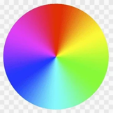  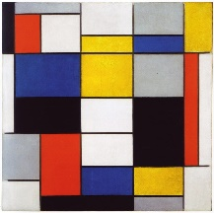 | Pop Art  Roy Lichtenstein  Drawing, painting, sculpture, 3D papier mâché.    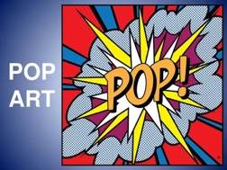 | Line/Pattern  Printmaking  Drawing, mark making, Polystyrene printing.  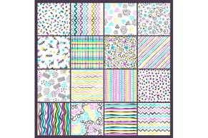  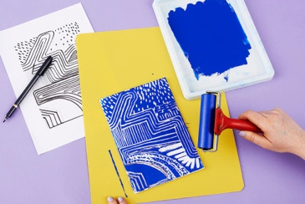 | Mask Making  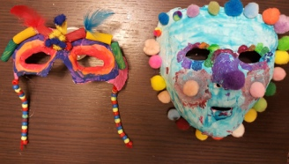 | Sculpture  Andy Goldsworthy  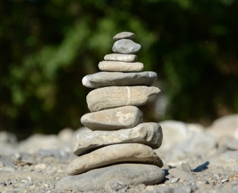  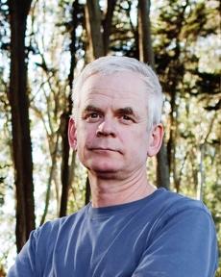
Pre-Teaching Assessment Suggestions | Before starting, assess:  Colour recognition: Can students identify red, blue, yellow?  Motor skills: Can they use brushes, glue, scissors?  Visual perception: Can they distinguish shapes and lines? Communication: Do they respond to visual prompts or verbal instructions?  Engagement: What sensory materials do they prefer or avoid?  Colour sorting games Simple shape and colour matching worksheets  Observation during free art play  Visual choice boards or PECS | Recall of previous learning – colour. Can Students: -name primary colours (red, blue, yellow). name secondary colours (orange, green, purple). spot shapes like stars or speech bubbles. match words like “BANG!” or “POP!” to sounds. draw big bubble letters. Use a paintbrush with control. cut, tear, and glue paper. shape soft materials (like playdough). talk about or point to Pop Art pictures they like. | Visual Pattern Recognition: Use flashcards with simple patterns and ask students to match or describe them.  Fine Motor Skills Check: Observe students using pencils, scissors, and rollers.  Sensory Engagement: Provide textured materials and ask students to describe or sort by feel.  Communication Assessment: Use visual prompts and simple questions to gauge understanding of 'line' and 'pattern'. | Observe students' comfort with tactile materials and textures.  Assess fine motor skills through simple cutting or moulding tasks.  Use visual prompts to gauge understanding of facial features and expressions.  Ask students to describe or point to parts of the face using flashcards or mirrors.  Provide simple drawing tasks to assess spatial awareness and creativity. | Observe students' ability to handle natural materials (leaves, stones, twigs).  Use visual prompts to assess understanding of 'sculpture' and 'nature'.  Conduct a simple matching activity with images of natural sculptures.  Assess fine motor skills through basic stacking or arranging tasks.  Use sensory exploration to gauge comfort with textures and outdoor materials.
‘Step On’ Knowledge | Primary Colours  Recognise and name red, blue, yellow  Use primary colours in painting and collage  Secondary Colours  Mix primary colours to create green, orange, purple Identify secondary colours in the environment  Mondrian’s Style  Recognise straight lines, rectangles, and primary colours in his work  Create simple Mondrian-inspired art using coloured paper or paint. | Recognise and use primary colours in their artwork. Use bold outlines and dot patterns like Roy Lichtenstein. Understand and use onomatopoeia words in visual art (e.g. “POP!”, “BANG!”). Draw and paint bubble letters with more control. Use a paintbrush carefully to apply flat, bright colours. Build a simple 3D shape using papier-mâché. Use cutting, tearing, and gluing with more confidence. Talk about their work using simple art words (e.g. colour, shape, loud, comic). Begin to make independent choices about colour, shape, and layout. | Explore different types of lines using drawing tools and string.  Use sensory boards to feel and trace lines.  Create a “line collage” using pre-cut strips.  Exploring Pattern  Look at patterns in nature and everyday objects.  Use stamps and sponges to create simple repeating patterns.  Introduce vocabulary: “repeat,” “same,” “different.”  Introduction to Printmaking  Demonstrate polystyrene tile printing with large, clear visuals.  Students press simple shapes into tiles using blunt pencils.  Practice printing with one colour.  Create a Patterned Tile  Support students in designing a simple repeating pattern.  Use tracing templates or stencils for guidance.  Print using two colours with adult support.  Cultural Patterns  Explore patterns from different cultures.  Create a tile inspired by one cultural pattern.  Use storytelling or music to enhance engagement.  Final Print Project  Students choose their favourite pattern and print it on fabric or paper.  Reflection & Sharing  Help students reflect.  Create a class gallery. | Introduction to Masks  Explore different types of masks (cultural, theatrical, animal).  Use images, videos, and real-life examples.  Create a mood board with magazine cutouts.  Designing a Mask  Use templates or face outlines.  Focus on simple shapes and bold features.  Encourage use of colour and texture.  Introduction to Mod Roc  Demonstrate how to apply Mod Roc to a plastic face mold.  Practice dipping strips and applying.  Begin building the base mask.  Building the Mask  Continue layering Mod Roc. Smooth and shape features with support.  Allow masks to dry.  Painting and Decorating. Use bold colours and simple patterns.  Add tactile elements (feathers, foam shapes, yarn).  Final Touches  Add straps or handles.  Reflect on the process using visual prompts. Share, evaluate, use sentence starters for peer feedback. Display by  Setting up a classroom gallery. | Introduction to Andy Goldsworthy  Show images and videos of his work.  Discuss how he uses natural materials.  Create a simple collage using leaves and twigs.  Exploring Materials  Collect natural items from school grounds.  Sort by colour, shape, and texture.  Create small arrangements indoors.  Building Sculptures  Use stones, sticks, and leaves to build simple sculptures.  Focus on balance and placement.  Outdoor Sculpture Creation  Create group sculptures outside using collected materials.  Photograph the finished work.  Patterns and Shapes  Explore spirals, circles, and lines in nature.  Recreate patterns using natural items.  Final Project  Plan and build a final sculpture.  Present and describe the work to peers.  Reflection  Use visual prompts to reflect on the process.  Create a display with photos and student comments
‘Extending up’ Knowledge | Introduce colour theory (warm vs cool colours)  Explore abstract art and compare Mondrian with other artists (e.g., Kandinsky) Use digital tools to recreate Mondrian-style art  Encourage independent choice of colours and layout in final pieces. | Mix primary colours to create secondary colours. Use a paintbrush with more control (e.g. staying in lines, even coverage). Create more detailed onomatopoeia designs using shapes and patterns. Explore animation or sound integration to bring onomatopoeia words to life. Build a more complex 3D shape using papier-mâché (e.g. adding layers or features). Use dot patterns more accurately and evenly. Begin to plan their artwork using a simple sketch or colour test. Talk about their work using more specific art vocabulary (e.g. bold, contrast, texture). Compare their work to Lichtenstein’s style and say what is similar or different. | Layering Prints: Print one pattern, let it dry, then print another on top using a different colour.  Pattern Collage: Cut out printed shapes and glue them into a new pattern.  Texture Exploration: Use textured rollers or sponges to add extra detail to prints.  Digital Patterns: Use a simple drawing app or interactive whiteboard to make patterns.  Fabric Printing: Print patterns onto fabric squares and turn them into useful items. | Introduce animal or fantasy-themed masks.  Use mirrors to explore facial expressions.  Create a group mask mural.  Explore digital mask design using simple apps.  Add 3D elements like horns or ears using cardboard. | Introduce simple land art concepts.  Explore colour gradients using leaves or flowers.  Use clay or dough to combine natural materials.  Create collaborative installations with peers.  Use digital tools to create nature-inspired designs.
Cross Curricular Links | Maths: Shapes (rectangles, squares), patterns, symmetry English: Describing colours and feelings, reading colour-themed books  Science: Colour mixing, light and colour  ICT: Digital art creation, interactive colour games PSHE: Expressing emotions through colour, teamwork in group projects | English: Onomatopoeia, comic strip writing, descriptive language. History: 1960s Pop Art context, post-war culture. ICT: Digital Pop Art, online research. DT: 3D sculpture design, material use. Maths: Shapes, measurement, symmetry. PSHE: Self-expression, media influence. Music: They connect sound words to instruments and rhythms. | Maths: Repeating patterns, symmetry, counting shapes.  English: Describing artwork using sentence starters.  Geography: Patterns from different cultures and countries.  Science: Exploring materials (polystyrene, ink) and their properties.  ICT- creating a repeat pattern. | English: Describe masks using adjectives; storytelling with masks.  Science: Explore materials (plaster, Mod Roc, paint).  History: Study masks from different cultures and time periods.  PSHE: Expressing emotions and identity through masks. | Science: Exploring materials, habitats, and seasons.  Geography: Understanding landscapes and natural environments.  Maths: Patterns, symmetry, and shapes.  English: Descriptive language and storytelling about sculptures.  PSHE: Teamwork, communication, and self-expression.
Careers in the Curriculum Opportunities | Introduce students to careers that use colour and art:  Artist: Explore how artists use colour to express ideas  Graphic Designer: Use of colour in logos and branding  Interior Designer: Colour schemes in rooms  Fashion Designer: Colour in clothing and trends  Set Designer: Use of colour in theatre and film | Artist Graphic Designer Comic Artist Animator Art Teacher Set/Prop Designer Web Designer Product Designer | Textile Designer. Interior Designer  Illustrator.  Art Technician | Theatre Designer  Special Effects Artist  Art Therapist  Costume Designer  Museum Curator | Environmental Artist  Landscape Designer Photographer  Park Ranger  Art Therapist Museum/Gallery Technician
LOtC Opportunities | Nature Walks: Identify colours in plants, animals, and surroundings  Visit to a Gallery or Museum: Look for Mondrian-style art or colour-themed exhibits  Outdoor Art Session: Use chalk, natural materials, or paint in the playground Photography Walk: Take photos of primary and secondary colours in the environment | Art gallery visit Sculpture Park visit Pop Art scavenger hunt (school grounds) Photography Walk – capture bold colours and patterns Outdoor chalk art – create Pop Art designs with onomatopoeia words like BANG! WOW! ZAP! | Nature Walk: Collect natural patterns (leaves, bark, stones).  Visit to Local Gallery: Focus on pattern-based artwork.. | Visit a local museum or gallery with mask exhibits.  Nature Walk to collect textures and inspiration.  Outdoor mask-making session in the playground. | Nature walks to collect materials.  Outdoor sculpture building sessions.  Visit to a local park or nature reserve. Display sculptures in school grounds  Invite a local artist to demonstrate land art techniques.

