Navigators – WSM, DBA, AMA, EEF
Term | Autumn 1 | Autumn 2 | Spring 1 | Spring 2/Summer 1 | Summer 2
Topic | Investigating Colour  Sonia Delaunay  Drawing, Painting.  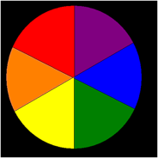  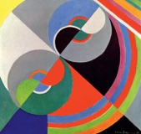 | Pop Art  Roy Lichtenstein  Drawing, painting, sculpture, 3D papier mâché.  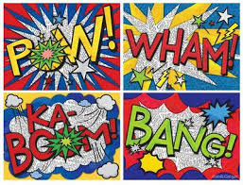  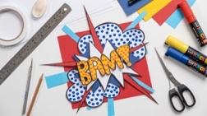 | Line/Pattern  Printmaking  Drawing, mark making, Polystyrene printing.  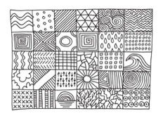  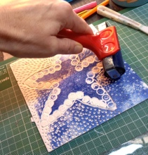 | Mask Making  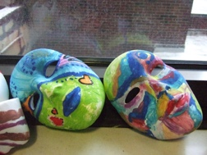 | Sculpture  Andy Goldsworthy.  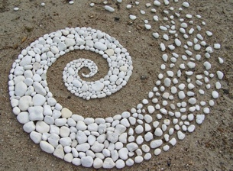  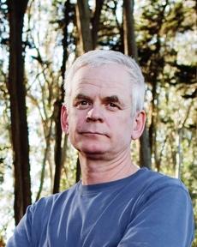
Pre-Teaching Assessment Suggestions | Can students correctly label a colour wheel correctly? Do they know Primary, secondary colours. Colour mixing activity. Can students mix colours correctly? Can students identify Warm or cool colours and relate these to emotions? Can students identify colour and shapes within Delaunay’s work? | Pop Art Knowledge  Have students seen comic-style art with words like BANG! or WOW!?” Onomatopoeia Understanding  Quick task: List or draw a favourite sound word. Papier-Mâché Experience  Have students used papier-mâché before?  Try shaping a letter with paper. Creative Planning  Sketch a bold word design using colour and shape. | Visual Pattern Recognition: Use matching activities with simple and complex patterns.  Drawing Skills Check: Ask students to draw different types of lines and simple shapes.  Tool Handling Observation: Watch how students use pencils, rollers, and scissors.  Vocabulary Check: Use flashcards or visuals to assess understanding of terms like “line,” “pattern,” “repeat,” and “print.” | Observe pupils' comfort with tactile materials and mask-related imagery.  Assess fine motor skills through simple cutting and shaping tasks.  Use visual prompts to gauge understanding of facial features and expressions.  Conduct a short discussion or matching activity on emotions and masks.  Evaluate ability to follow multi-step instructions with visual aids. | Visual recognition: Show images of natural sculptures and ask students to describe what they see.  Fine motor skills: Observe students manipulating natural materials (stones, leaves, sticks).  Communication: Use visual prompts and simple questions to assess understanding of “natural,” “sculpture,” and “pattern.”  Engagement: Note students’ responses to outdoor environments and tactile materials.
‘Step On’ Knowledge | Build on prior learning and knowledge of primary and secondary colours to explore colour groups like complementary and analogous colours. Use prior learning of colour mixing to create tints (lighter colours) and shades (darker colours). Build upon previous Learning About Warm and Cool Colours  Talk about how colours can show feelings like calm, excitement, or sadness. Show how colours can express different feelings or moods in their artwork. Explore how colours can mean different things in different cultures or situations. Use a paintbrush with control and precision to make different strokes, lines, and textures. Look at Sonia Delaunay’s art and describe how she uses colour, shape, and pattern. To recreate a Sonia Delaunay-style artwork using bold colours and repeating shapes. To understand how colours can have different meanings in different places or cultures. | Build on prior learning and knowledge of colour from previous topic. Explore vibrant colours. Pop Art style and themes  Understanding of who Roy Lichtenstein was. Roy Lichtenstein’s comic-inspired techniques. Onomatopoeia as visual sound words. Art elements: colour, line, shape, form Basic understanding of 3D and papier-mâché processes Sketching bold comic-style words Painting with flat colour, dots, and outlines Building 3D letterforms, basic construction, building layers, gluing and assembly of materials, applying papier-mâché layers Planning and expressing creative ideas visually. | Exploring Line  Introduce types of lines (straight, curved, zigzag, wavy).  Use drawing exercises and tactile tracing activities.  Identify patterns in nature, textiles, and architecture.  Create simple repeating patterns using stamps or drawing.  Introduce concepts of symmetry and repetition.  Introduction to Printmaking  Demonstrate how to use polystyrene tiles for printing.  Students press designs into tiles using blunt pencils.  Practice printing with one colour.  Designing a Patterned Tile  Plan a repeating pattern using lines and shapes.  Transfer design onto polystyrene tile.  Print using two colours with support.  Cultural Pattern Inspiration  Explore patterns from different cultures (e.g., Islamic tiles, Aboriginal art).  Create a tile inspired by a cultural pattern.  Final Print Project  Students design and print a final piece on paper or fabric.  Focus on neatness, colour choice, and pattern clarity.  Reflection & Presentation  Use sentence starters or visual prompts to reflect on their work.  Create a class gallery and give peer feedback  Display work in classroom/corridor. | Introduction to Masks  Explore different types of masks (cultural, theatrical, emotional).  Use images and real-life examples to spark discussion.  Pupils sketch simple mask designs.  Planning a Mask  Discuss purpose and emotion behind each mask.  Pupils choose a theme and plan their mask using templates.  Building the Base  Demonstrate how to create a mask base using Mod Roc and a plastic face mold.  Pupils begin layering Mod Roc with support.  Shaping and Refining  Pupils refine mask shape and add features (nose, eyebrows, etc.).  Use clay or paper to build up areas before Mod Roc application.  Painting and Decorating  Pupils paint masks using chosen colours and patterns.  Add decorative elements (feathers, beads, fabric).  Final Touches  Pupils complete masks and prepare for display.  Reflect on design choices and process.  Presentation and Reflection  -Pupils present masks to peers.  Use sentence starters and visuals to support reflection. | Introduction to Andy Goldsworthy  Explore Goldsworthy’s work using images and videos.  Discuss the use of natural materials and outdoor settings.  Exploring Natural Materials  Collect and sort materials by texture, colour, and shape.  Create simple arrangements indoors.  Creating Temporary Sculptures  Use leaves, stones, and twigs to create temporary sculptures.  Photograph the work for documentation. Pattern and Shape  Explore patterns in nature.  Create spiral or circular arrangements using natural materials.  Collaborative Sculpture  Work in small groups to create larger outdoor sculptures.  Focus on teamwork and shared decision-making.  Final Project  Plan and create a final sculpture using chosen materials.  Document the process with photos and simple descriptions.  Reflection and Presentation  Use sentence starters and visuals to reflect on the experience.  Present work in a class gallery or slideshow.
‘Extending up’ Knowledge | Invent a Colour Scheme – Show a mood or idea using your own colour choices. Use New Materials – Mix paint with collage, fabric, or digital tools. Create in Delaunay’s Style – Make your own version with new shapes and colours. Explain Your Choices – Talk or write about how your colours tell a story. Compare Artists – Look at how other artists use colour differently. | Art History: Compare Lichtenstein with other Pop Artists (e.g., Warhol, Haring) to explore different styles and messages. Typography & Design: Study how font, scale, and layout affect impact in visual communication Mixed Media: Introduce new materials (e.g., wire, foam, LED lights) to enhance 3D word sculptures. Sound & Movement: Explore animation or sound integration to bring onomatopoeia words to life. Personal Voice: Encourage students to choose words that reflect their identity, culture, or emotions. | Layered Printing: Print one design, let it dry, then add another layer.  Colour Mixing: Explore how colours change when layered.  Digital Pattern Making: Use simple apps to create patterns.  Fabric Printing: Print onto fabric squares or tote bags. | Introduce mask-making from other cultures (e.g., African tribal masks, Venetian masks).  Explore storytelling through masks and role-play.  Use digital tools to design masks on tablets.  Create a group mask project with a shared theme. | Introduce simple land art techniques like stacking stones or leaf mosaics.  Explore seasonal changes and how they affect materials.  Use digital tools to create patterns inspired by nature.
Cross Curricular Links | Maths – Students use shapes, symmetry, and patterns in their abstract designs. Literacy – They write about their colour choices and describe their artwork. History – They learn about Sonia Delaunay and the time she lived in. Science – They explore how colours are seen and how they mix. Music – They link rhythm and movement in music to patterns in their art. | English: Students explore onomatopoeia in poetry and comics. Maths: They measure and plan 3D letter shapes. History: They learn about Roy Lichtenstein and the Pop Art movement of the 1960s. Science: They investigate the properties of papier-mâché materials. Computing: They design digital word art or sculpture mock-ups. Music: They connect sound words to instruments and rhythms. | Maths: Symmetry, tessellation, shape recognition.  English: Descriptive writing about artwork and process.  Geography: Cultural patterns from around the world.  Science: Properties of materials (ink, polystyrene, paper). | English: Descriptive writing about mask characters.  History: Cultural significance of masks in different societies.  Science: Properties of Mod Roc – reversible/irreversible and materials used.  PSHE: Exploring emotions and self-expression through mask design. | Science: Materials and their properties, seasonal changes.  Geography: Natural environments and landscapes.  Maths: Patterns, symmetry, and shapes.  English: Descriptive language and storytelling about sculptures.
Careers in the Curriculum Opportunities | Artist / Painter. Textile or Fashion Designer. Graphic Designer. Interior Designer. Art Teacher | Graphic Designer Illustrator / Comic Artist Set Designer / Prop Maker Art Teacher / Educator Marketing / Advertising Professional Digital Artist / Animator Museum / Gallery Curator | Textile Designer:  Graphic Designer  Illustrator  Art Technician | Theatre Designer:  Special Effects  Art Therapist  Museum Curator | Environmental Artist  Landscape Designer  Photographer  Park Ranger  Art Therapist
LOtC Opportunities | Go on a colour walk to spot bright colours and take a photo using the I pad. Look for shapes in the buildings and signs around the grounds. Visit an art gallery to see abstract art. Make chalk art on the MUGA - drawing bold circles and colours. | Visit a modern art gallery or museum Attend a comic art or graphic design workshop Explore a theatre or set design studio Invite a local artist for a school workshop Hold a school Pop Art exhibition | Nature Walk: Collect natural patterns (leaves, bark, stones).  Visit to Local Gallery or Museum: Focus on pattern-based artwork. | Visit a local museum or gallery with mask exhibits.  Organize a nature walk to collect textures and materials.  Display masks in a communal area. | Nature walks to collect materials and observe patterns.  Outdoor sculpture sessions in the school grounds.  Visit to a local sculpture trail.

