Pioneers – JPR, ADA BTEC/AQA units
Term |  | Autumn 1, 2, Spring 1 | Spring 2/Summer 1 | Summer 2
Topic | Printmaking Techniques  Drawing, printing, etching,  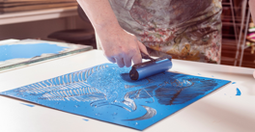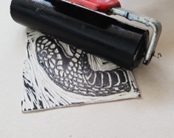  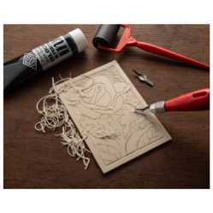 |  | Creating a 3D Art object.  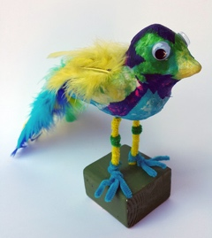  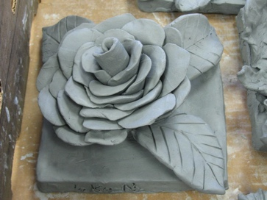 | Artist Research Project.  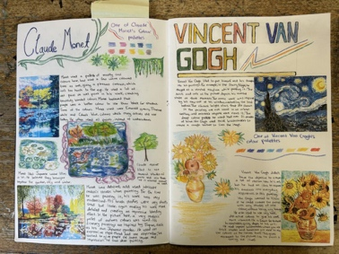  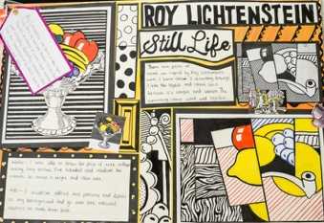
Pre-Teaching Assessment Suggestions | Have students heard of or tried printmaking before? Discuss where we see print and show examples, wallpaper, wrapping paper. Ask students to recall previous learning – polystyrene prints. Check if they know what block printing, stencilling, silk screen or lino printing are. Show pictures and ask them to guess how the prints were made. Discuss and explore the various tools required for the different printmaking styles. Ask if they know what a pattern or repeated design is. Talk about shapes and spaces (positive and negative space). Ask what they think happens when you press ink onto paper. |  | Assess students' understanding of basic 3D shapes and forms.  Evaluate prior experience with materials such as clay, cardboard, wire, or Mod Roc.  Observe fine motor skills and ability to follow visual or verbal instructions.  Use visual prompts and discussion to gauge interest and confidence in 3D art.  Identify any sensory or physical needs that may affect material handling | Use visual prompts to gauge recognition of famous artists and styles.  Discuss students’ prior knowledge of art history and personal preferences.  Observe communication and comprehension skills using artist images and vocabulary.  Assess ability to follow instructions and use basic art tools.
‘Step On’ Knowledge | What printmaking is: Making pictures by putting ink on a surface and pressing it onto paper.  Different types of printmaking: Block printing – using a block with a design to make repeated prints. Stencilling – using cut-out shapes to make patterns with paint or ink. Lino printing – carving a design into soft lino, adding ink, and pressing it onto paper. Mono printing – making a one-off print by drawing or painting on a smooth surface and pressing paper onto it. Silk screen printing – using a screen and stencil to push ink through and create a design, often on fabric or paper. Tools and materials: Learning the names and uses of things like rollers, ink, blocks, stencils, and carving tools, screens and smooth surfaces for mono printing. Design skills: Making bold, simple designs that are easy to print. Understanding which parts of the design will show up (positive and negative space). Planning a design that can be repeated or printed more than once. How to print: The steps to make a print: design, prepare, ink, and press. How to use tools safely, especially when carving lino. Art words: Learning words like print, pattern, stencil, relief, screen, mono print and texture. |  | Introduction to 3D Art  Explore examples of 3D art objects and sculptures.  Discuss materials and tools used in 3D art.  Create simple 3D forms using paper or card.  Planning a 3D Object  Sketch ideas and discuss purpose and function.  Select materials and plan construction steps.  Building the Structure  Begin constructing the base form using chosen materials.  Focus on stability and shape.  Adding Detail and Texture  Use additional materials to add surface texture and features.  Explore techniques such as layering, carving, or wrapping.  Surface Decoration  Paint or decorate the sculpture using appropriate finishes.  Consider colour, pattern, and theme.  Final Presentation  Complete and present the finished 3D object.  Reflect on process and outcomes through discussion or written feedback. | Introduction to Art Research  Explore what it means to research an artist.  Introduce key vocabulary: artist, style, medium, influence.  Choose an artist to study (e.g., Van Gogh, Frida Kahlo, Keith Haring).  Gathering Information  Use books, videos, and websites to learn about the chosen artist.  Create a fact sheet or visual board with key information.  Exploring Artistic Style  Analyse the artist’s use of colour, line, shape, and texture.  Practice techniques used by the artist.  Planning a Recreation  Select a piece of the artist’s work to recreate.  Sketch and plan materials needed.  Creating the Artwork  Begin recreation using appropriate materials.  Focus on technique and style.  Completing and Presenting  Finalize artwork and prepare for presentation.  Write or record a reflection on the process.  Peer Review and Evaluation  Share work with peers and provide feedback.  Discuss what was learned and what could be improved.  Curate a mini exhibition in school.
‘Extending up’ Knowledge | Knowing the differences between each type of printmaking and choosing the best one for their design. Using more colours and layers in their prints and lining them up carefully. Creating more detailed designs that show thought and planning. Trying new materials like fabric or textured paper to see different effects. Fixing mistakes and finding ways to improve their prints. Looking at artists’ work and talking about how they use printmaking. Talking about their own work – what went well, what they would change next time. Using more art words like layer, positioning texture, and contrast. Using tools with care and precision, such as carving neatly, rolling ink evenly, and pressing prints properly. Following health and safety rules, especially when using sharp tools like lino cutters or handling printing ink. |  | Introduce mixed media sculpture combining found objects.  Explore installation art and environmental sculpture.  Use digital tools to plan or visualize 3D designs.  Encourage independent research into artists and techniques. | Compare two artists and explore differences in style.  Create a new artwork inspired by the studied artist.  Explore digital tools to recreate or remix the artist’s work.  Write a short biography or create a presentation about the artist
Cross Curricular Links | Maths: Patterns, symmetry, measuring, and sequencing steps. English: annotation of work, using art vocabulary, reflecting on work. Geography: Exploring print styles from different cultures. Science: Learning about materials, pressure, and how ink transfers. History: Studying famous printmakers and how printing was used in the past. Computing: Designing prints digitally or editing scanned artwork. |  | Maths: Geometry, measurement, spatial awareness.  English: Descriptive writing, reflective journaling.  Science: Material properties, structural integrity.  History: Cultural significance of sculpture across time.  ICT: Digital design and documentation. | English: Writing artist biographies and reflections.  History: Understanding the historical context of the artist’s life.  Using technology for research and digital art creation.  PSHE: Discussing personal expression and emotional impact of art.
Careers in the Curriculum Opportunities | Printmaker / Artist Graphic Designer Textile Designer Illustrator Art Teacher Screen Printer Pattern Designer Gallery or Museum Worker |  | Sculptor  Set designer  Prop maker  Product designer  Architect  Museum/gallery technician  Model maker for animation or film | Artist  Art Historian  Museum Curator  Art Teacher Illustrator  Graphic Designer
LOtC Opportunities | Visit an art gallery or museum to see real printmaking examples. Take a trip to a print studio or invite a local printmaker to demonstrate techniques. Explore patterns in nature (e.g. leaves, bark, flowers) to inspire print designs. Create outdoor prints using natural textures like leaves or rubbings. Photograph textures and patterns outside to use in print designs back in class. |  | Visit local sculpture parks or public art installations.  Use outdoor spaces for large-scale or natural material sculpture.  Display work in school grounds. | Visit a local gallery or museum to view artist works.  Organize a nature walk to inspire artistic observation.  Display student work in school.  Invite a local artist for a workshop or talk.

