Pathfinders – MGW, EEF, SDE, JJO
Term | Autumn 1 | Autumn 2 | Spring 1 | Spring 2/Summer 1 | Summer 2
Topic | Investigating Colour  Sonia Delaunay  Drawing, Painting.  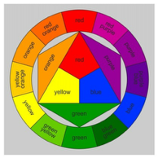  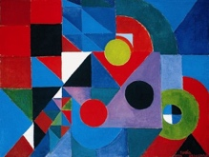 | Pop Art  Roy Lichtenstein  Drawing, painting, sculpture, 3D papier mâché.  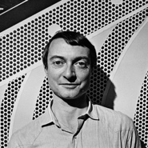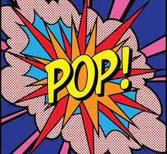  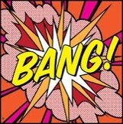 | Line/Pattern  Printmaking  Drawing, mark making, polystyrene/Lino printing.  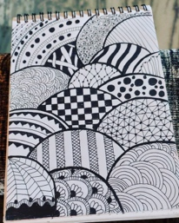  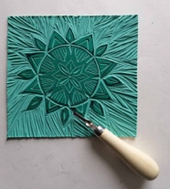 | Mask Making  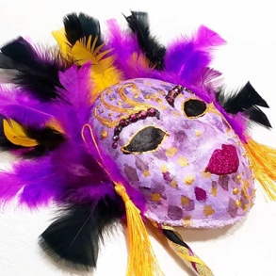 | Sculpture  Andy Goldsworthy  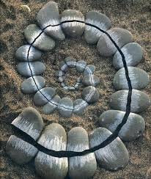  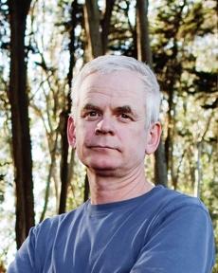
Pre-Teaching Assessment Suggestions | Basic Colour Knowledge: Ask if students know primary, secondary, and tertiary colours. Can they name or point to them? Show a Sonia Delaunay painting. Ask what colours and shapes they see. Students try a quick drawing using bright colours and simple shapes. Ask if they’ve heard of Sonia Delaunay or seen abstract art before. Listen for simple words like “bright,” “circle,” “pattern,” or “mix.” | Pop Art Knowledge: Do students know what Pop Art is or Lichtenstein’s comic style? Art Vocabulary: Check understanding of words like bold, dots, onomatopoeia. Painting Skills: Assess use of bold colours, outlines, and dot patterns. 3D Skills: Ask about experience with papier-mâché and sculpting. Word Creativity: Explore use of sound words like “BANG!” or “WOW!” in designs. | Visual Pattern Recognition:  Use matching and sorting activities with complex patterns.  Drawing Skills Audit: Ask students to draw varied lines and shapes with increasing complexity.  Tool Proficiency: Observe use of pencils, rollers, and cutting tools.  Vocabulary Understanding: Use flashcards and verbal prompts to assess comprehension of key terms.  Creative Thinking: Encourage students to describe where patterns appear in real life. | Assess fine motor skills through simple sculpting or clay tasks.  Use visual prompts to gauge understanding of facial features and expressions.  Discuss or show examples of masks from different cultures and ask students to describe them.  Observe students’ ability to follow multi-step instructions.  Use simple questionnaires or visual checklists to assess prior knowledge of 3D materials. | Visual recognition: Show images of natural sculptures and ask students to describe what they see.  Fine motor skills: Observe students manipulating natural materials (twigs, leaves, stones).  Communication: Use visual prompts to assess vocabulary related to nature and sculpture.  Creative thinking: Ask students to arrange natural objects into a simple pattern or shape.
‘Step On’ Knowledge | Build on prior learning and knowledge of primary, secondary, and tertiary colours. Identify complementary colours and their effects. Understand warm vs. cool colours and their moods. Use key terms: contrast, pattern, abstract, blend. Use a paintbrush with control and confidence. Build on prior learning of Mixing colours accurately, including tertiary  and complementary. Create repeated shapes and patterns inspired by Delaunay. Look at Sonia Delaunay’s art and describe how she uses colour, shape, and pattern. To Use a paintbrush with control and precision to make different strokes, lines, and textures. To recreate a Sonia Delaunay-style artwork using bold colours and repeating shapes. To plan and explain colour choices in final artwork. | Recall comic-style drawing from earlier lessons or personal interests. Understand Pop Art as a movement using bold colours, outlines, and everyday imagery. Recognise onomatopoeia (e.g. “BANG!”, “WOW!”) and link to sound words in comics. Learn about Roy Lichtenstein and his use of Ben-Day dots and speech bubbles. Explore 2D to 3D: Build on drawing/painting skills to create 3D forms with papier-mâché.  Develop joining and cutting skills using scissors and craft knives with care. construction, building layers, gluing and assembly of materials, applying papier-mâché layers Planning and expressing creative ideas visually. To build on prior learning and knowledge of colour from previous topic and Use colour theory to apply bold primary secondary and tertiary colours from prior colour mixing lessons. | Advanced Line Exploration  Explore expressive lines and line weight.  Create abstract compositions using varied line styles.  Complex Pattern Recognition  Analyse patterns in architecture, textiles, and nature.  Create symmetrical and tessellated patterns.  Printmaking Techniques  Demonstrate polystyrene/Lino tile printing with layering.  Students design and carve detailed patterns.  Colour and Composition  Experiment with colour theory in printmaking.  Create multi-layered prints with complementary colours.  Cultural Pattern Study  Explore global patterns (e.g., Celtic knots, mehndi, Islamic geometry).  Create culturally inspired prints.  Final Project  Design and print a final piece on fabric or paper.  Focus on composition, technique, and presentation.  Reflection and Critique  Use structured peer critique and self-assessment.  Present work in a class gallery. | Introduction to Masks  Explore the purpose of masks in different cultures and performances.  Sketch basic mask designs using facial outlines.  Planning a Mask  Develop a personal or character-based mask design.  Choose colours, shapes, and textures.  Building the Base  - Use plastic face molds to create the base structure.  Apply Mod Roc strips with guidance.  Sculpting Features  Add raised features (nose, eyebrows, etc.) using Mod Roc or card.  Smooth and refine the surface.  Painting and Decorating  Paint the mask using chosen colour schemes.  Add embellishments (feathers, sequins, fabric).  Final Touches and Reflection  Complete decoration and evaluate the final piece.  Present masks and discuss design choices. | Introduction to Andy Goldsworthy  Explore Goldsworthy’s work using images and videos.  Discuss the use of natural materials and outdoor settings.  Create a simple nature collage.  Exploring Natural Materials  Collect and sort natural materials by texture, colour, and shape.  Create a group sculpture using found objects.  Pattern and Shape in Nature  Identify patterns in leaves, bark, stones.  Create a spiral or radial pattern using natural materials.  Temporary Sculpture  Discuss the idea of impermanence in Goldsworthy’s work.  Create a sculpture outdoors and photograph it.  Personal Sculpture Project  Plan and sketch a sculpture using natural materials.  Build the sculpture with support.  Reflection and Presentation  Present sculptures to the class.  Reflect using sentence starters or visual prompts.  Display or Outdoor Exhibition  Set up a sculpture trail or display in a school grounds.
‘Extending up’ Knowledge | Explore analogous and split-complementary colour schemes. Investigate how colour affects mood and meaning in abstract art. Study Delaunay’s influence on fashion, design, and modern art movements. Compare Delaunay’s work with other abstract artists (e.g. Kandinsky, Mondrian). Experiment with layering colours and transparency effects. Create a digital version of their artwork using design software or apps. | Learn more about Ben-Day dots and how they were used in printing. Talk about how colour and size make art stand out. Look at other Pop Artists like Andy Warhol and compare styles. Try using different materials together (paint, paper, sculpture Make more detailed papier-mâché sculptures. Develop skills with cutting tools – scissors and craft knives. Create sound words like “ZAP!” or “CRASH!” in bold designs. Learn how Pop Art was inspired by comics, adverts, and everyday life. Use a computer or tablet to make Pop Art digitally. | Explore linocut techniques.  Use digital tools to design patterns.  Create pattern books or portfolios.  Investigate historical printmakers and their styles.  Combine printmaking with other media (e.g., collage, painting). | Introduce mixed media (e.g., LED lights, sound elements).  Explore mask-making in theatre and film.  Create a group performance using the masks.  Research and replicate historical or ceremonial masks.  Use digital tools to design masks before building them. | Introduce environmental art and sustainability.  Explore land art by other artists (e.g., Richard Long).  Use digital tools to design sculptures.  Create a time-lapse video of sculpture creation.  Experiment with adding sound or movement to sculptures.
Cross Curricular Links | Maths: Shapes, symmetry, pattern, and measurement. English: Art descriptions, artist biography, and speaking about artwork. History: Delaunay’s life in the context of 20th-century events. Science: Light and colour mixing (additive vs. subtractive). DT: Textile and pattern design inspired by Delaunay. Computing: Digital art and presentations. PSHE: Colour and emotion, cultural appreciation. | English: Use and create onomatopoeia words (e.g. “BANG!”, “WOW!”); write comic-style captions or short stories. Maths: Explore shapes, patterns, and scaling in artwork; count and space Ben-Day dots. History: Learn about the Pop Art movement and the 1960s cultural background. Science: Discuss sound words (onomatopoeia) and how sound travels. DT (Design & Technology): Build papier-mâché sculptures and explore 3D design. Computing: Create digital Pop Art using drawing apps or design software. (canva) PSHE: Talk about self-expression and how art can reflect feelings or popular culture. | Maths: Geometry, symmetry, tessellation.  English: Art vocabulary, descriptive writing.  History: Cultural origins of patterns and printmaking.  Geography: Global art traditions.  Science: Materials and their properties.  Computing: Create digital prints/patterns using drawing apps or design software. | English: Character development and storytelling.  History: Cultural and historical significance of masks.  Drama: Use masks in performance and role-play.  Science: Materials and their properties.  PSHE: Exploring identity and emotions through mask symbolism. | Science: Materials and their properties, seasons, habitats.  Geography: Natural landscapes, environmental awareness.  English: Descriptive writing, storytelling inspired by sculptures.  Maths: Symmetry, pattern, measurement.  PSHE: Teamwork, self-expression, emotional regulation through nature.
Careers in the Curriculum Opportunities | Artist / Painter.  Textile or Fashion Designer.  Graphic Designer. Interior Designer. Art Teacher | Graphic Designer Illustrator / Comic Artist Set Designer Art Teacher Marketing Advertising Digital Artist Museum / Gallery Curator | Textile Designer  Graphic Designer  Illustrator  Printmaker Art Therapist  Museum/Gallery Curator | Theatre Prop Designer  Special Effects Artist  Costume Designer  Art Therapist  Museum Curator  Set Designer | Environmental Artist  Landscape Architect  Garden Designer  Photographer  Art Therapist  Museum/Gallery Educator
LOtC Opportunities | Go on a Colour Walk: Look for bright colours in nature, buildings, clothes, and signs. Use the iPad to capture images. Visit a Gallery or Museum: See real artwork and talk about colours and shapes. Outdoor Painting: Take paints outside and use colours from the environment. Find Patterns: Spot shapes and patterns in fences, pavements, or windows. Take Photos: Use a phone or tablet to take pictures of interesting colours and patterns. Make Digital Art: Try drawing colourful shapes using an app or computer outside. Chalk Art: Use coloured chalk to draw Delaunay-style circles and patterns on the MUGA or quad area. | Chalk Art: Draw comic-style words and dots on the MUGA or quad area. Pop Art Walk: Spot bold colours and signs in the school environment. Gallery Visit: See modern or Pop Art in real life. Sculpture Trail: Explore public 3D art for inspiration. Photo Task: Take pictures of everyday objects to turn into Pop Art. Outdoor Making: Paint or build papier-mâché sculptures outside. | Visit local galleries or museums with printmaking exhibits.  Nature walks to collect pattern inspiration.  Use the iPad to capture images around school.  Outdoor printing in school grounds. | Visit a local theatre or museum with mask exhibits.  Outdoor mask-making workshop.  Collaborate with a local artist or theatre group.  Display masks in a communal space.  Participate in a cultural festival or themed event. | Nature walks to collect materials and observe patterns.  Outdoor sculpture building sessions.  Visit to a sculpture park.

